Sixth  December 2023  Edition 10  Year in Review Sailing in 2023  Photos by John Sverre  2023  Just for Laughs  let's face it ...you have to laugh if you are crazy enough to race through the winter!  Frome  Some Common Sailing terminology:  Sailing: The fine art of getting wet and becoming ill while slowly going nowhere at great expense.  Anchoring: A process during which the anchor is lowered and rancor id heightened.  Boom: Laterally mounted pole to which a sail is fastened. Named for the sound it makes when it hits the crew’s head.  Calm: Sea conditions characterized by the simultaneous disappearance of the wind and the last cold beverage.  Foul Weather Gear: Weatherproof clothing needed only in the fall , spring, winter and summer months.  Galley:  - Ancient: Aspect of seafaring associated with slavery.  - Modern: Aspect of seafaring associated with slavery.  Hazard: Any boat in the SCYC fleet over 2 feet in length.  Knot: A connection of one or more lines that Graham is not allowed to tie while on Janes’s Addiction.  Marina: A commercial dock facility having up-to-date facilities for the disposal of excess amounts of currency that may have accumulated on board causing a fire hazard.  Oilskin: Irritating epidermal condition suffered by boat owners who work on diesel engines.  Passenger: A form of movable ballast which tends to accumulate on the leeward side of sailboats once sea motions commence.  Nautical Knowledge  What is the origin of “Don’t sweat the small stuff”?  Peter Heiberg has come up with this piece of history.  In the times of the sailing ships, crew members would heave on heavy lines (halyards, sheets, etc.) working up a sweat in the process. Lighter lines for trimming were called the small stuff and took less effort to work. Hence the expression “Don’t sweat the small stuff”. | Sunshine Coast Yacht Club Newsletter  Welcome to our nineth edition. Don’t forget to check out our website. Thanks to David Pritchard, David Guy and Tomek Maszkowski who do a fabulous job of keeping the site updated. www.scycsailing.ca  The Sunshine Coast Yacht Club has experienced an extremely active year. The membership has demonstrated commitment to their craft with pride and skill. Members have accounted well for themselves with outstanding results around the coast. Below are some of the members’ achievements outside of our club events:  2023 SCYC Successes  Boat Skipper Crew Event Result  Aura Ignacio Vuilliez David Guy Round Bowen 1st in Division 8th Over All  Alatus Vatche Yerevanian Huei Jen, Cliff Sutton, Richard Osborne Southern Straits Short Course 1st in Division 7th Over All  Matilda Anna Richley Doug Kiloh RNSA Double Handed 1st Overall  Janes Addiction Rolf Braun Anna Richley, Neil Ripley, Graham Gee Malaspina Regatta 1st Over the Line 1st in Division 2nd Over All  Additionally, Richard Poole achieved a very respectable 7th out of 31 boats in Division 3 in the Round Bowen  Results and details of all the club series in 2023 are posted in the Club Racing pages of the SCYC website (https://www.scycsailing.ca/club-racing). Congratulations not only to the winners but also to all who participated. It is clear from how tightly the fleet crosses the finish lines that the entire fleet has raised its game.  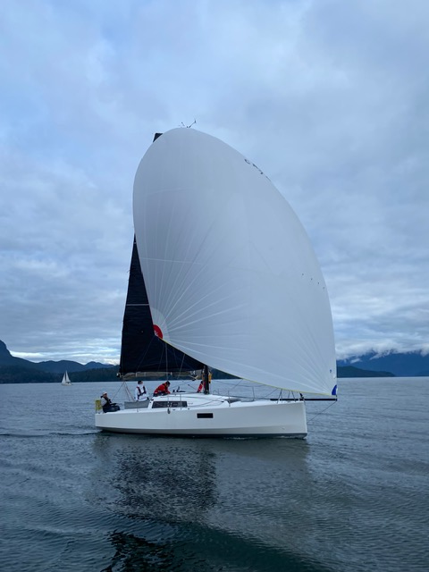  The calendar of events for 2024 has been posted on the website www.scycsailing.ca. Find the calendar link on the home page. Events of note are the New Years Day race (Skippers meeting at 11:15), Ad-hoc racing on January 7 and the 2024 Winter Series starts January 28.  Mark Evans will be conducting a 1-hour “Introduction to Sailboat Racing and SCYC” at 3PM prior the AGM to promote and raise interest in the club.  We intend to hold the AGM at the Blackfish Pub again on March 24th at 4PM. You must be a paid-up member to vote at the AGM. If you are interested in serving on the executive, please contact any of the current board members.  Meet a member – Neil Ripley  When did you start sailing?  My first sailing experience was a dinghy sailing summer camp as a kid on Lake Fanshawe outside London Ontario. I was hooked from the start with the near magical feeling of the dinghy gliding along over the lake. That was followed a few years later wind surfing at another summer camp in the Muskoka’s. Getting the windsurfer up on plane and sailing across the lake was thrilling. However, due to various factors I was away from sailing for many years until I moved to Vancouver. I resumed sailing in about 2007 through the Jibset sailing club, then based out of Granville Island.  What is your favourite boat that you have owned or sailed on?  I was part of the Ambleside Yacht Co-op in Vancouver, and the membership co-owned a CS30 named Take Five. That boat was nearly perfect for me. It was a great experience to be involved with the club and take part in maintenance and management of the boat that we all owned a share in. I took that boat on day sails and on several cruises over to the Gulf Islands and up to Desolation Sound. I have to say though that racing on Jane’s Addiction over the past 18 months has been an amazing opportunity. When the weather conditions cooperate, and we get Jane’s screaming along on plane I get giddy. It puts a smile on me that lasts until the next week.  Where is your favourite cruising destination?  This is a really difficult question because there are so many wonderful places to cruise around here. I think that Desolation Sound is a definite favourite area to explore and I aim to get back up that way in the future. I want to get back to Refuge Cove on West Redonda Island and Gorge Harbour on Cortes Island in particular. Lots of good memories up there and lots more nooks and crannies to explore.  What is your best racing moment?  I have been racing since I joined the Jibset in 2007. Early on my racing was on Martin 242s and then Martin 244s with various Jibset crews for many Wednesday night and Friday night races in English Bay. I was also regularly part of Huntly Gordon’s crew on his boat Flyway out of RVYC. With Huntly I raced as his navigator and radio operator in a few Swiftsure races and a few Southern Straits. One of those Southern Straits races experiences stands out. It was an incredibly warm spring evening and the nearly full moon rose as we were making our way across the strait somewhere off Halibut Bank. We were ghosting along under spinnaker and it was such an incredibly breathtaking experience to witness the moon rise over the fleet. To this day that moon rise stands out as fantastic experience.  What is your favourite drink on board?  I really enjoy a good cup of hot tea with one cream and one sugar. Best enjoyed with friends on a bright cool winter day while sailing around the islands. Back at the dock a nice IPA after a hot summer day racing goes down very smoothly.  When did you join RCM-SAR? When did you retire?  I joined the Gibsons RCM-SAR unit in 2013, a few months after I moved here with my family. I joined the unit partly to give back to the marine community as I felt I had been relying on SAR services while taking part in all those various races, cruises and just generally sailing around. It seemed like something I had to do. As it turned out it was also a great way to make connections in the local community and build up my marine skills. I served nearly 10 years with the unit with nearly 4 years as the station leader and 6 years as a coxswain commanding the vessel on training rides and call-outs. Earlier this year though I decided my time had come to retire from the organization. I have been retired from the unit since September.  How many call-outs were you involved in?  My 100th call-out happened in early September just a few days before I stood down from the unit.  What was your most satisfying/rewarding rescue mission?  It is hard to pick just one but there was one mission a few years ago in the early spring where we were called out to investigate a report of a signal fire on Gambier Island near Mariner’s Rest. I was commanding that mission and as we approached the area, we spotted an individual up on a cliff waving his arms and shouting for help. We helped him down off the cliff and got his story. He was mildly hypothermic and clearly distraught. He had been making his way from Gibsons heading to Squamish via Britannia Beach in a small and apparently heavily loaded down run-about. He took a wave over the stern of the boat from a passing tug and before he knew it, he was swimming for shore. His boat went down almost immediately and all he had on him was a cigarette lighter and his truck keys. He used the lighter to start a few signal fires and was waiting up on the cliff for a few hours until someone on the opposite shore noticed the fires and called 911. Strangely he kept asking us where his motorcycle was. We were confused about this but he explained that he had tied his lifejacket to his motorcycle that he had loaded on his boat. He was hoping that the lifejacket would keep his motorcycle floating. We explained to him that his lifejacket was most likely still tied to his motorcycle but both were about 200 feet down now. I then had to send SAR crew scrambling up the cliff to extinguish his signal fires. He had been very proficient at setting those fires and it took the crew a few trips with a bucket to put them all out. We then transported him to the boat launch at Britannia Beach where he was met by his very relieved brother. Helping that guy get home safely was very satisfying. It could have turned out very badly for him as the water was super cold and if he had been just a bit further offshore or got tangled up in gear on his boat the story could have had a much grimmer outcome. A good reminder to be prepared.  Unfortunately, it was not a completely happy ending from his perspective as neither his boat nor his motorcycle have ever been recovered to my knowledge.  That’s just one story. There are many more. Some funny and some sad but all rewarding. Happy to share more stories after a Sunday race dockside over an IPA.  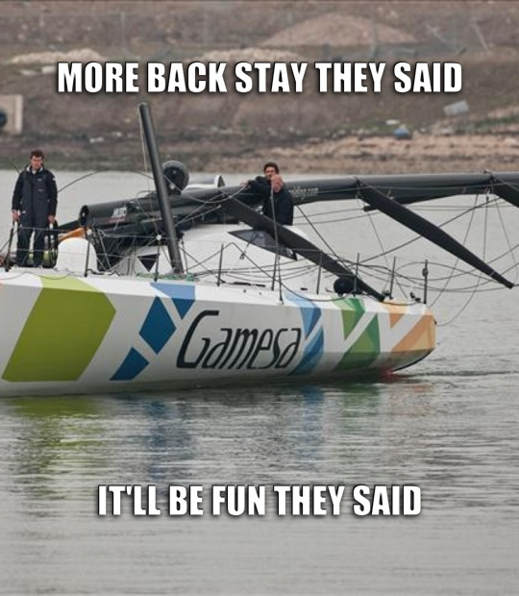  2023 Opti National Championships  The following article was written by Mark Evans who helped judge the event. Mark is a Sail Canada certified Club Judge and Sail Canada certified Club Race Officer.  The 2023 Opti National Championships were held from August 21st to August 27th 2023 at the West Vancouver Yacht Club. The “Opti” short for Optimist, is a sailing dinghy designed in 1947 by Clark Mills and standardized into a “one design” in 1995. The Opti is one of two sailboats accepted as an International Class boat by World Sailing for sailors under 16 years of age.  There were 92 competitors from across Canada and Washinton State including 76 Volunteers and some 14 staff members ranging from maintenance and repairs on support, competitors’, and committee vessels. Volunteers making and planning meals, setting marks, coaches and, of course, Judges.  I was honored to participate as a certified Sail Canada Judge in such a well-run event. The judging team consisted of Chief Judge Thomas (Tom) Sitar, myself, Jennifer Ross, and Robert Woodbury.  Tom is an experienced racer and National Judge. Jennifer Ross is an experienced Club Judge and National Race Officer, President of BC Sailing and the Vice Commodore of the Vancouver Rowing Club. Robert Woodbury is a past Olympic sailor, experience Club Judge and National Race Officer who is also the Chair of the BC Sailing, Race Committee Program.  Official opening ceremony was held August 21st at Dundarave Park in West Vancouver. The following morning, and every morning after 92 Optis were launched in under 18 minutes and the fleet sailed, sculled or were towed to the race course. The participants were divided into below 9-year-old (green fleet) which held their own separate races. The National Fleet was ages above 9 to 15 made up National participants who were divided differently each day into 4 flights. Unfortunately, as is the pariah in our sport, the wind did not always cooperate. There were several races that were recalled due to light winds and the current pushing most of the fleet over early and a number of races that were started and abandoned due to the changing or disappearing winds. Not counting the races that were started, postponed, recalled, or abandoned, there were 6 completed races consisting of 2 starts and two flights in each race. One race, two flights, another start for two more flights.  Judging activities began on the water each morning watch and calling infraction to rule 42 (propulsion). Prohibited actions include “sculling” (moving the tiller back and forth in quick succession), “Ouching” (throwing your weight forward). “Pumping” (rocking the boat to pump the sail) or a combination of these will propel the vessel.  I was also involved in some protest hearings. It was nice to be a panel member rather than the “Chair”.  Judging also involved arbitration which is like a protest hearing however it is only binding if both parties agree to an outcome. This method is preferred in some cases as the “rule breaker” vessel takes a scoring penalty rather than following a protest hearing, the “rule breaker” vessel would be disqualified in that race.  The regatta was 4 days of solo races and one day of team racing. Team racing requires on the water “Umpires”. An Umpire will settle protests on the spot. Should the offending vessel believe that they broke a rule she would raise their hand and do a one turn penalty. If they did not believe that they broke a rule they would not raise their hand. The Umpire would then uphold the protest by raising a red flag or disagree with the protest and exonerate the protested boat by raising a Green and White flag.  I am very impressed with the racers, the coaches and the organizers. I hope to be able to participate in more regattas and continue gaining experience as a Sail Canada judge.  Mark Evans  ….and on the topic of judging, the following link from Kim Davies makes interesting reading. The message I took from the discussion is ‘have a look’. As Kim says, “it’s not the *@##&!% Olympics. So if there is any doubt, give way.  https://www.racingrulesofsailing.org/posts/2027-rule-10-and-14?forum_id=1  Remember to look out for the notice for the annual general meeting until then:  See you on the water!

